A
PROJECT REPORT
ON
PHARMACY
FOR
MEDICINES
BY

RITIKA PARASHAR

BCA-SEM VI



Deccan Education Society’s
MARATHWADA MITRA MANDAL’S COLLEGE OF COMMERCE
(B.C.A DEPARMENT)
Deccan Gymkhana,
PUNE-411004
UNIVERSITY OF PUNE
2018-2019

MARATHWADA MITRA MANDAL’S COLLEGE OF COMMERCE
BACHELOR OF COMPUTER APPLICATION
302/A, Deccan Gymkhana, PUNE-411004

CERTIFICATE
(TO WHOMSOEVER IT MAY CONCERN)
This is to certify that the following students
RITIKA PARASHAR
Have completed the project entitled
PHARMACY TRACKING SYSTEM
In a particular fulfillment for the award of
BACHELOR OF COMPUTER APPLICATION
UNIVERSITY OF PUNE
In the academic year 2018-2019
This work has been carried out by then under my supervision and Guidance
Ms. Nita Patil
Submitted by:
RITIKA PARASHAR

Prof.Nita Patil Dr.Sandip Anpat Dr. M.D.Lawrence External Examiner
(Guide) (HOD) (Principal)

ACKNOWLEDGEMENT

We express our deep sense of gratitude to our respected and learned guide, Asst. Prof. Ms. Nita Patil for their valuable help and guidance, we are thankful to them for the encouragement they have given us in completing the project. We are also thankful to all the other faculty and staff members of our department for their kind co-operation and help. Lastly, we would like to express our deep appreciation towards our classmates and our parents for providing us the moral support and encouragement.

Ritika Parashar

(BCA SEM VI)

INDEX

SR.NO | PARTICULARS | PAGE NO
1 | INTRODUCTION
 | INTRODUCTION TO SYSTEM | 1
 | SCOPE OF SYSTEM | 2
 | PROPOSE SYSTEM | 3
2 | SYSTEM ANALYSIS
 | FACT FINDING TECHNIQUE | 7
 | FEASIBILITY STUDY | 9
 | HARDWARE REQUIREMENTS | 11
 | SOFTWARE REQUIREMENTS | 11
3 | SYSTEM DESIGN
 | E-R DIAGRAM | 12
 | CONTEXT LEVEL DIAGRAM | 13
 | DATA FLOW DIAGRAM | 14
 | FILE DESIGN | 17
 | DATA DICTIONARY | 22
4 | FORM DESIGNING(SCREEN SHOTS) | 24
5 | REPORTS | 27
6 | LIMITATIONS | 30
7 | ADVANTAGES AND DISADVANTAGES | 31
8 | FUTURE ENHANCEMENT | 32
9 | BIBLOGRAPHY | 33

INTRODUCTION

TO

SYSTEM

Introduction Project
PMIS basically deals with the maintenance of drugs and consumables in the pharmacy unit.
■ The system will ensure availability of sufficient quantity of drugs and consumable materials for the patient.
■ This will enhance the efficiency of clinical work, ease the patients convenience and process drug prescriptions effectively.
■ The system will help removing time wasting, saving resources, allow easy access to medicine, as well as bring on more security on the data compared to manual based system.
■ Information and Communication Technology plays a great role in different fields and areas. Health case system is one area which is also affected.
■ It is necessary to ensure a technologically appropriate, efficient, affordable, environmentally adaptable and consumer friendly system to benefit the health care industry.
■ For this reason, Pharmacy Management Information System (PMIS) is being built.

SCOPE OF THE SYSTEM

- User Interface: User interface is so much good that operators feel good to operate the software. Minimum problem in working. This software is very user friendly, this software is give user proper help to operation the software.
- Graphical User Interface: GUI is good so the operators cannot bored by working screen user can work very fresh mind. By watching screen.
- Processing speed: Processing speed of the software is so much good to operate fast quick save data & print receipt.
- Flexible: Existing system is so much flexible that can be changed according to the operators and customers.
- Automatic generation of the Reports: This software is able to automatically generate the report and documents.
- Error Free: software is error free because of error handling with sufficient validations.
- Security: This software is use only who know the login id or password, lock system is in this software.
- Man Power: Only one man to operate the system.

PROPOSED SYSTEM

- Enhancement: The main objective Pharmacy Management System is to enhance and upgrade the existing system by increasing its efficiency and effectiveness. The software improves the working methods by replacing the existing manual system with the computer-based system.

- Accuracy: The Pharmacy Management System provides the uses a quick response with very accurate information regarding the users etc. Any details or system in an accurate manner, as and when required.

- User-Friendly: The software Pharmacy Management System has a very user-friendly interface. Thus the users will feel very easy to work on it. The software provides accuracy along with a pleasant interface. Make the present manual system more interactive, speedy and user friendly.

- Availability: The transaction reports of the system can be retried as and when required. Thus, there is no delay in the availability of any information, whatever needed, can be captured very quickly and easily.

- Maintenance Cost: Reduce the cost of maintenance.

- Security: This is very important aspect of the design and should cover areas of hardware reliability, fall back procedures, physical security of data and provision for detection of fraud and abuse.

SYSTEM
ANALYSIS

FACT FINDING TECHNIQUE
Various fact-finding techniques used during the requirement analysis stage of the project are as follows.
Interview :
This technique is used to collect information from individuals. It is an art better learned from practice than from book. It is invaluable technique together qualitative information, opinion policies and suggestion understanding problems. Interview proved to be the best source of qualitative information for development of the system.
Observation :
Observation the actual process helped a lot in finding details about various problems faced by the people during the operations. It helped in better understanding of the system. Observation can bring in missed facts, new way to improve the existing system, duplicate work dine inadvertently etc. observation can bring in what other fact-finding methods cannot.
Questionnaires :
Most of the questions were open ended to get feel of opinions and experience to explore or problems whenever detailed information was needed.
The users were prompted to elaborate more until the points were clear.

FEASIBILITY STUDY
Feasibility Study is an important phase of system’s development life cycle where the proposed system is received and evaluated to determine the usability & feasibility of the system.
The proposed system was reviewed considering following feasibility tests.
Technical Feasibility
Economic Feasibility
Behavioral Feasibility
TECHNICAL FEASIBILITY
The necessary setup (software & hardware) required for the system already exists, the system could run efficiently in present hardware setup.
The organization is well equipped with system Platform, since the platform provide accuracy reliability, ease of access and data security, and all the process involved in the system are information based.
The process system provides adequate and timely status information to end users

ECONOMICAL FEASIBILITY
Cost of hardware/software:
The hardware/software setup required for development and efficient operations of the system is available so the cost incurred is low.
The cost of developing the system is much less the benefits that will be provided by the proposed system. Hence the proposed system is economically feasible.
BEHAVIOURAL FEASIBILITY
The system will have required validations and checkpoints, which will reduce errors and inconsistency in the database. Hence performance of the system is enhanced.
The proposed system will provide timely information and status of various activities to management and end users. It will facilitate the usage of the system.

HARDWARE & SOFTWARE REQUIREMENT
Hardware Requirement :
The existing system can be installed on Desktop Computer.
The minimum required configuration of the computer is:
Processor : Pentium III or Above
Monitor : VGA
Hard Disk : MIN space 1GB
RAM : MIN 256 MB
Printer : Any type as per requirement
Keyboard101 KEYS
MousePS2/ Serial

Software Requirement :
Operating System : Windows 10
Front End Tool : Visual Studio 8
Back End Tool : Microsoft Access

System Design

E-R Diagrams:

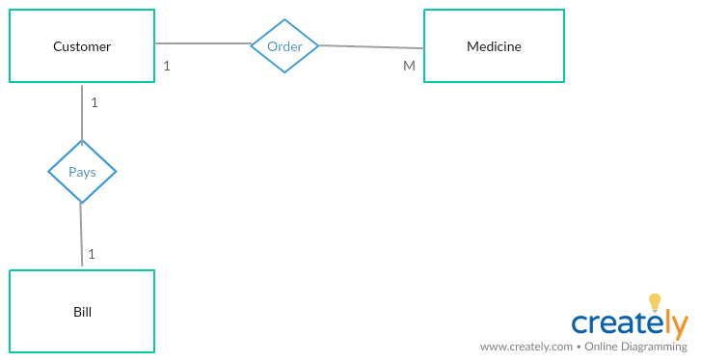

CONTEXT LEVEL DIAGRAM

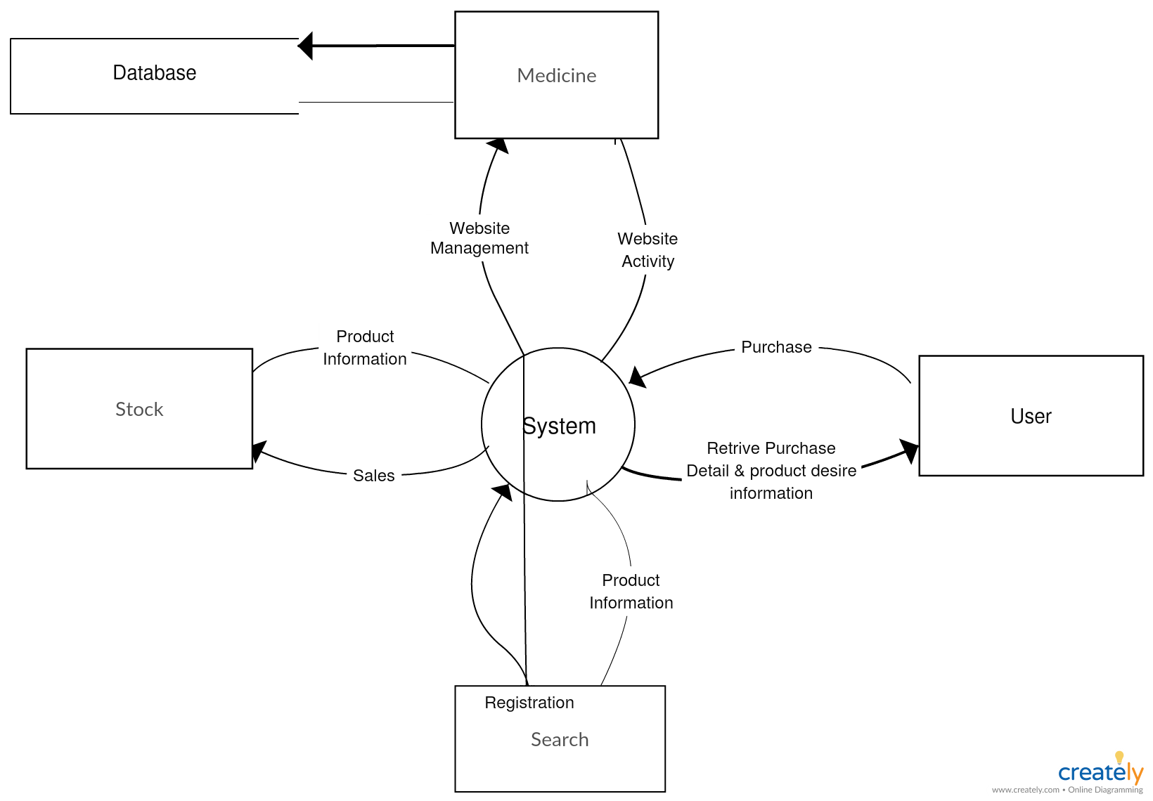

DATA FLOW DIAGRAM
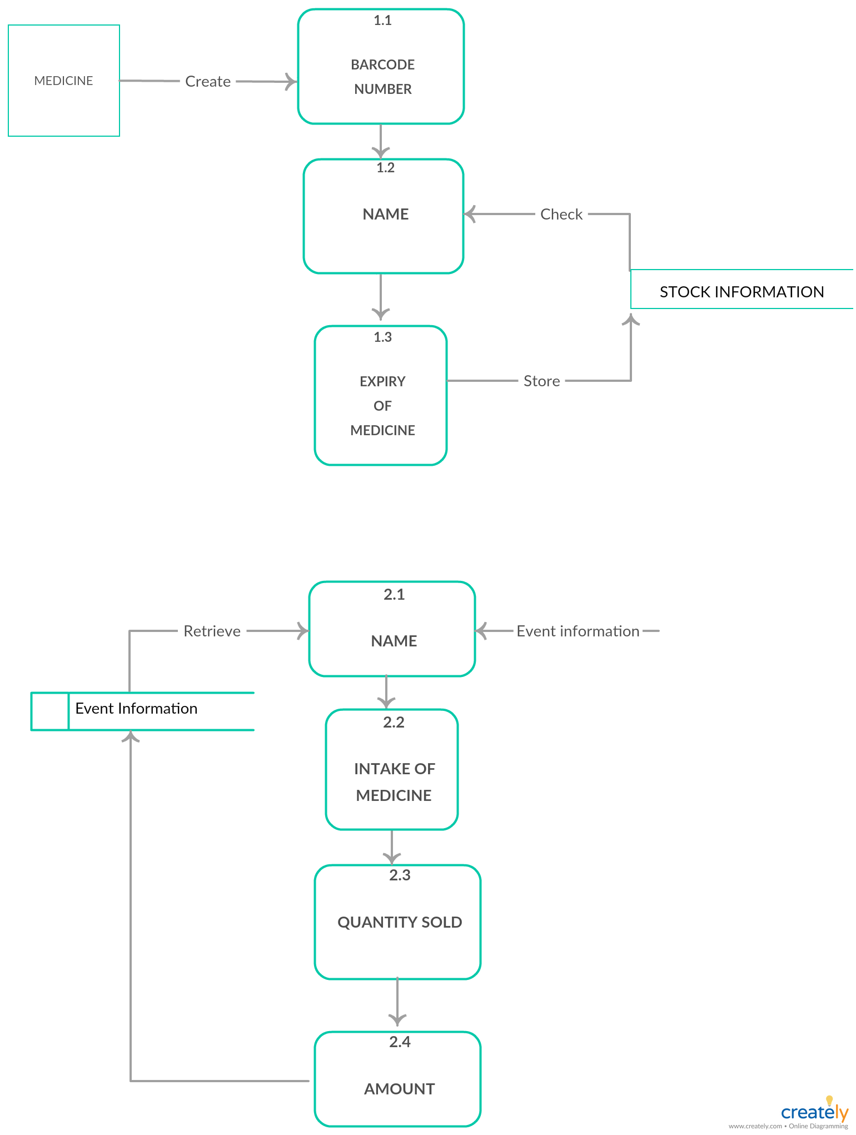

FILE DESIGN

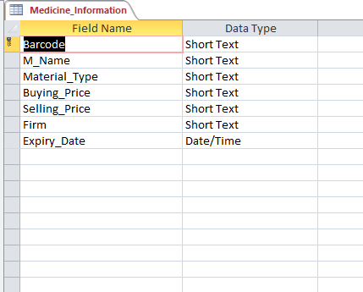

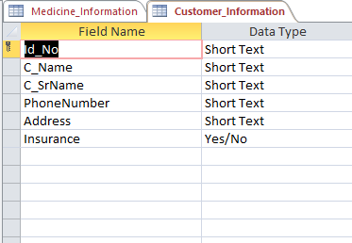

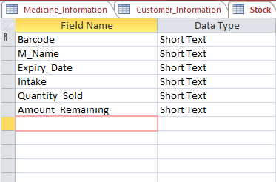

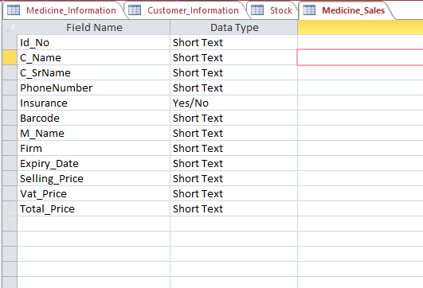

DATA
DICTIONARY

Fields | Type
Medicine Barcode | Number
Medicine Name | Text
Buying Price | Number
Sales Price | Number
Grower Firm | Text
Expiration Date | Number
Id no | Number
Name | Text
Surname | Text
Telephone | Number
Address | Text
Medicine Barcode | Number
Medicine Name | Text
Expiration Date | Number
Intake | Number
Quantity Sold | Number
Amount Remaining | Number
Id no | Number
Fields | Type
Name | Text
Surname | Text
Address | Text
Medicine Barcode | Text
Medicine Name | Number
Expiration Date | Number
Sales Price | Number
VAT Price | Number
Total Price | Number

FORM
DESIGN

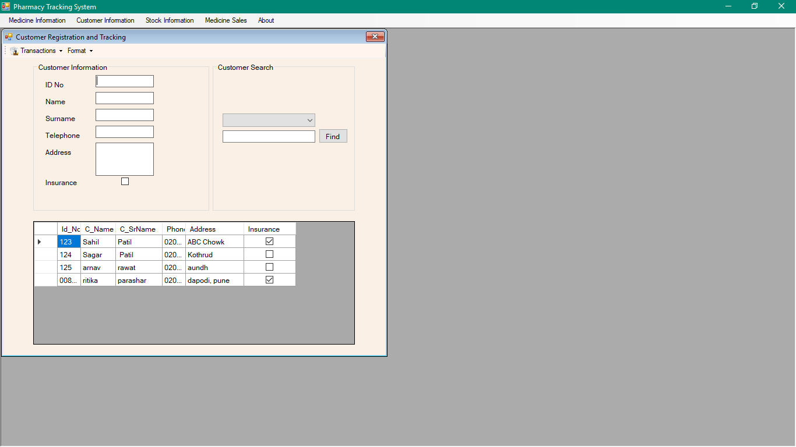

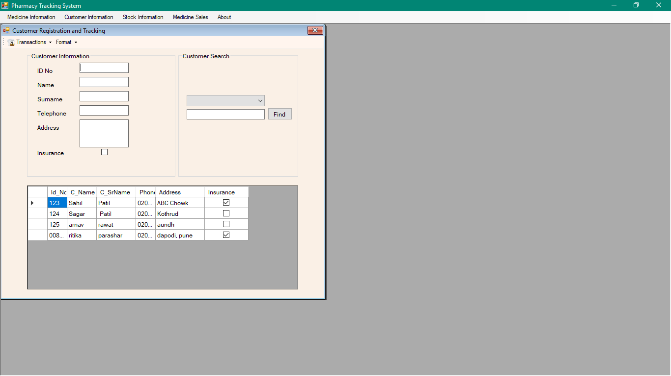

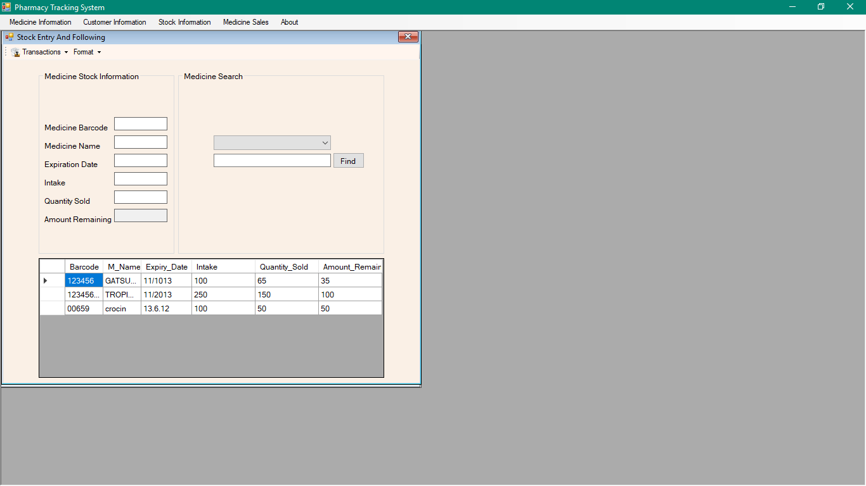
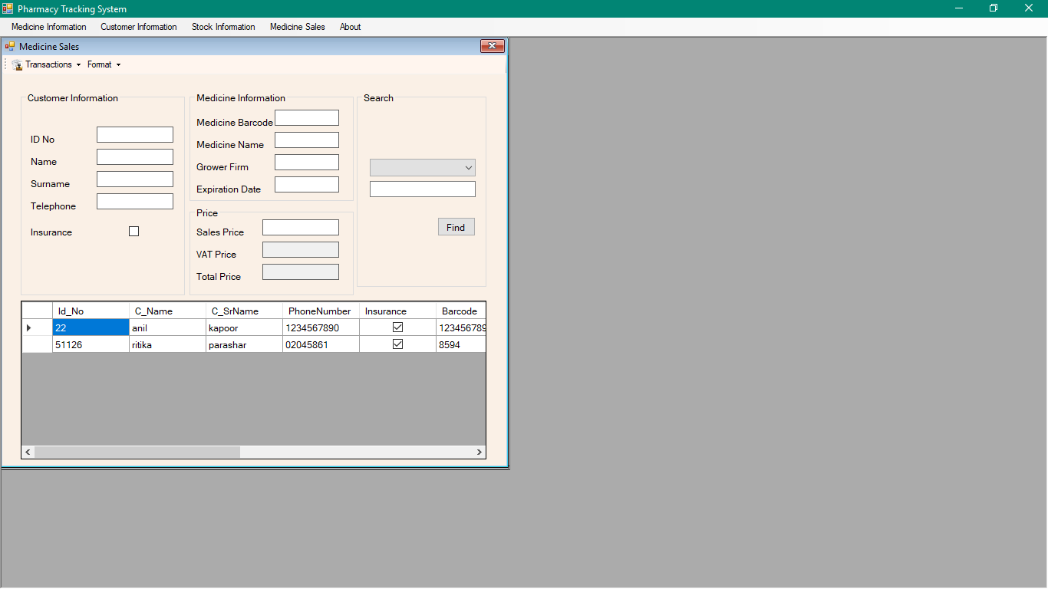

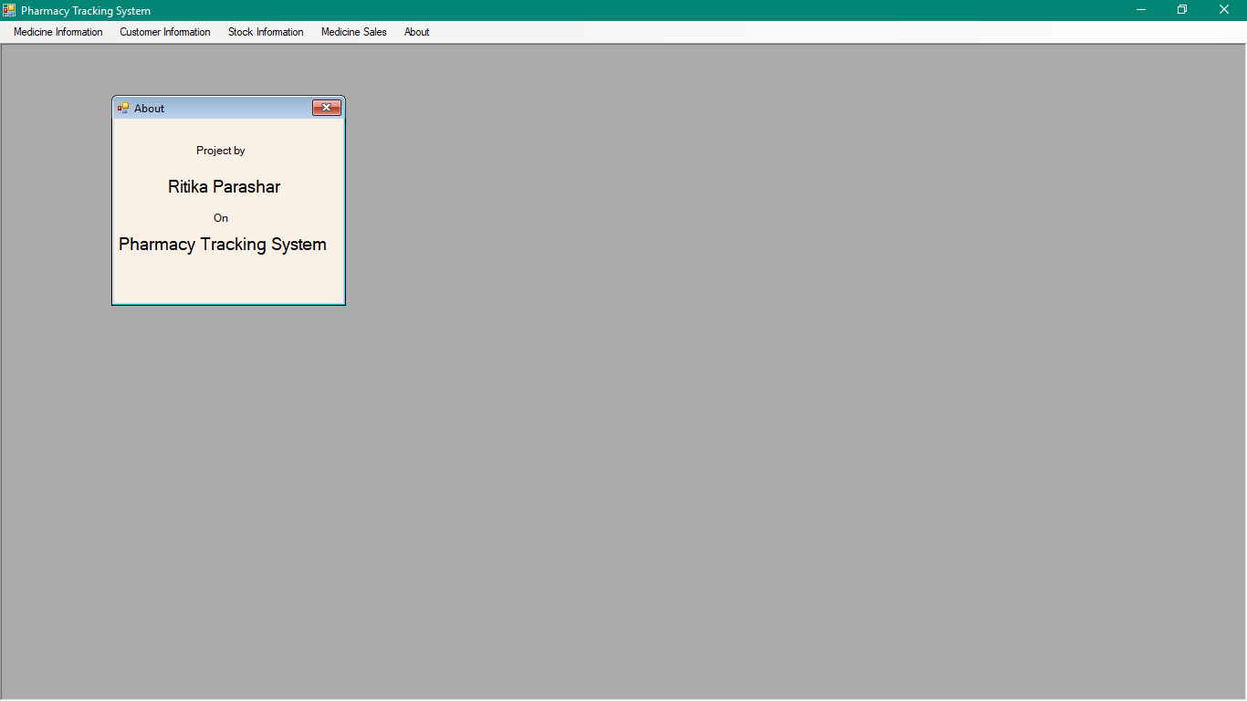

ADVANTAGES
AND
DISADVANTAGES

- Advantages :-

- Reduce Paper works
- Increases Profitability
- Increases Goodwill
- Reduce Manpower
- Increases Effeciency
- Save Time
- Provides Quick Access
- Reduces drawback of Manual System

- Limitations :-

- Current system handled by only one user.
- Orders cannot be placed by customer.

Future
Enhancement

Future Enhancement

- System can be provided with backup facility.

- An administration module can be designed to track of various types of deferred transaction and accordingly updated data and consistency of database.

- Payment made be available.

BIBLOGRAPHY

BIBLOGRAPHY
It mentions the books that have been referred while developing the system.
- Visual Basic 10 ultimate
- Database Programming with studio 2008
- Mastering V.B;
- Database Management system: Henry F.Korth
- Black Book: Elias M.Awad
- M.S Access at your Tips: Julian George

